## Number of tweets per year and month:

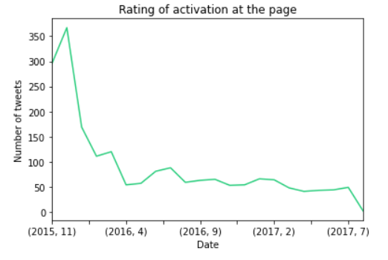

From above figure we can notice that the activation (number of tweets) is decreasing. As the number of tweets increase from (2015-11) to (2016-1), but it is decreasing from (2016-1) to (2017-7).

## Retweeting & Favoriting count over time

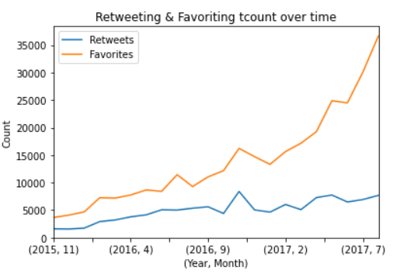

From the plot we can see that the number of retweet and favorite is increasing by time.

## The algorithm how is successful most

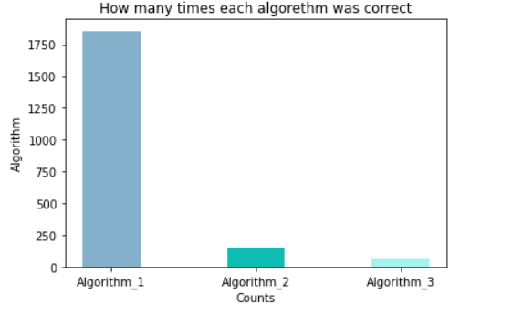

We can see from the plot that algorithm one is the most successful algorithm

## Most frequent doges type

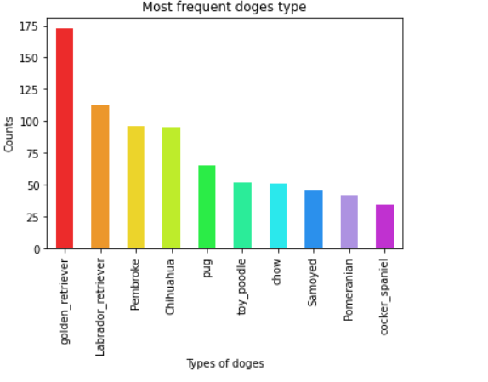

From above plot we can notice that the most frequent dogs’ type is golden retriever, Labrador retriever, Pembroke, Chihuahua, pug, toy poodle, chow, Samoyed, Pomeranian, and cocker spaniel

## Common source for tweets

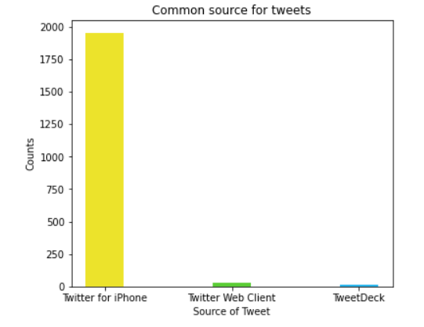

In the previous figure we can notice that the most common source for tweet is iPhone.

## Common dogs’ names

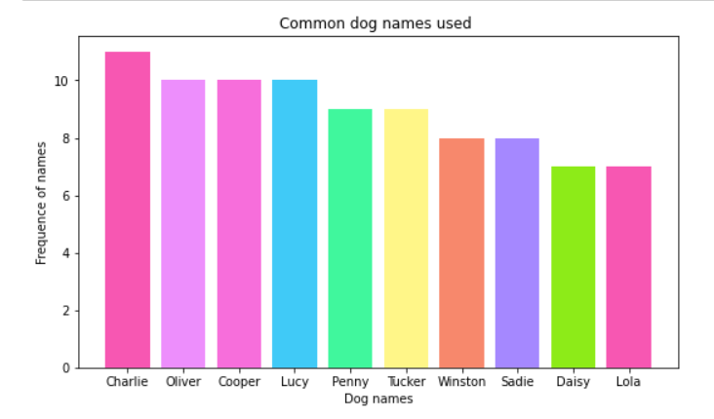

The most common names for doges are 'Charlie', 'Oliver', 'Cooper', 'Lucy', 'Penny', 'Tucker', 'Winston', 'Sadie', 'Daisy', and 'Lola'.

## Counts of retweet and favorite according to doge’s type

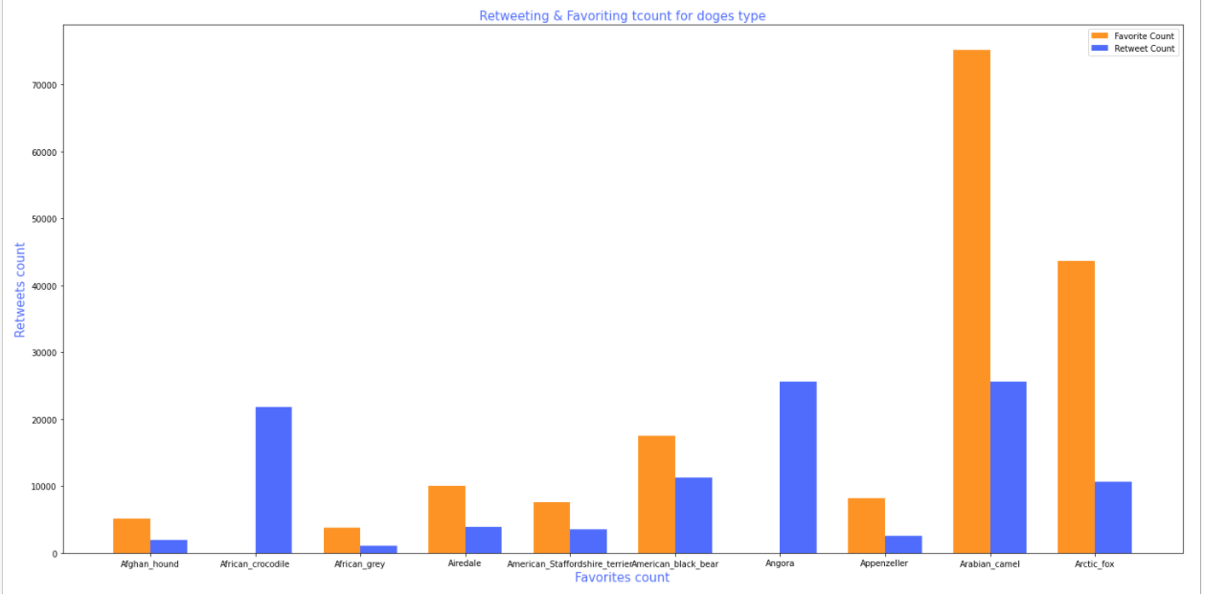

The above plot shows the relation between dog type and (favorite and retweet) count and we can notice that Arabian camel take high favorite count and retweet count